Week 1: Nutrition & Diet | Week 2: The Digestive System | Week 3: The Periodic Table
diet the kinds of food that an organism habitually eats  nutrient a substance that is essential for survival  carbohydrate a nutrient found in foods such as pasta, rice, bread and potatoes  protein A nutrient found in food such as meat, eggs, fish and tofu  lipid a nutrient found in foods such as oil, butter, nuts and seeds.  obesity when someone has such a high excess of body fat that their health might be affected  The table shows why we need each nutrient:  Nutrient Use in the body  Protein For growth and repair  Carbohydrates To make energy  Lipids (fats and oils) To provide energy and Insulate against the cold  Vitamins Maintain health  Minerals Maintain health  Water For cells and body fluids  Fibre Keeps food moving through the gut | organ system a group of organs that work together  digestive system the organ system responsible for taking in and breaking down nutrients  Pancreas Makes enzymes  bacteria In digestion, bacteria break down substances that we cannot  small intestine an organ in the body where nutrients are absorbed into the blood  enzyme a biological catalyst that speeds up chemical reactions in the body  The diagram shows the parts of the digestive system and their function.  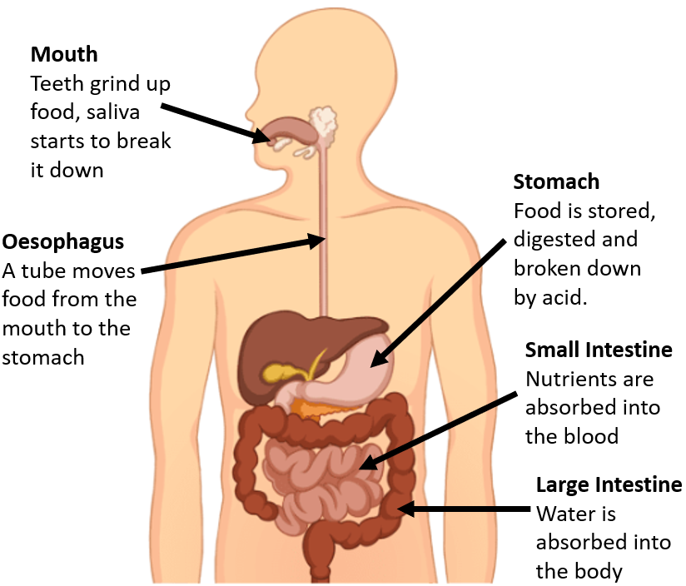 | the periodic table a chart showing all of the chemical elements  property feature of a chemical substance or material  group a column of elements in the periodic table  period a row of elements in the periodic table  prediction a statement about what you think will happen  variable any factor that can be controlled, changed, or measured in an experiment ​  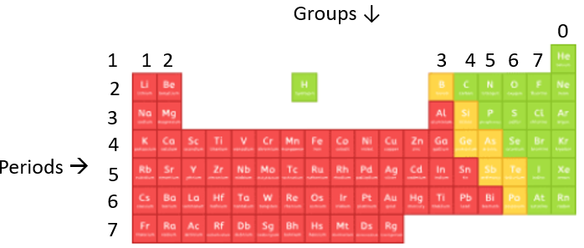  Water (H₂O) and Carbon dioxide (CO₂) are not on the periodic table of elements because they are compounds.

